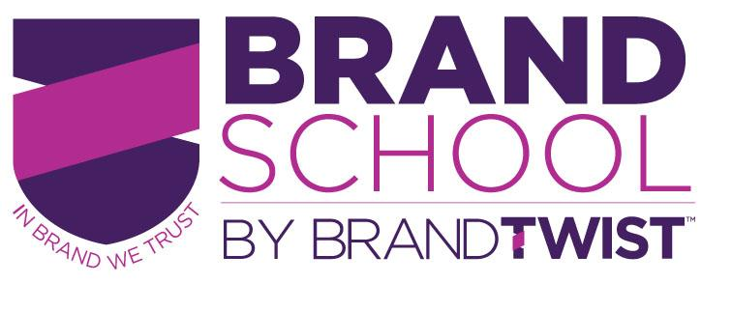

BRAND SCHOOL SESSION 1: BRAND DIAGNOSTIC EXERCISE

A healthy brand is an entrepreneur’s secret weapon. This Diagnostic is meant to help identify areas where your brand needs some focused attention and perhaps areas where you brand excels (and could be pushed further) as we move through Brand School.

DIAGNOSTIC
Circle one answer (yes/no/kinda) for each question, and then write down any observations about how your brand can be working harder in these areas. If you are at the beginning stages of your brand building, think about how these areas could be leveraged in the future to bring your brand to life. Write down any specific ideas you could strengthen or build your brand in these areas. These don’t have to be fully thought out concepts, just capture anything that comes to mind now after seeing the video and reading these questions.

CLARITY
- Can you give your elevator pitch (including what’s unique about you) in 1 minute or less?
(Circle one) Yes/ Kinda/ No - Write any observations on areas for improvement/new practices:

- Are you targeting everyone and at risk of connecting with no one?
(Circle one) Yes/ Kinda/ No - Write any observations on areas for improvement/new practices:

- Do you know what’s at the top of your benefit pyramid (your compelling Brand Promise)?
(Circle one) Yes/ Kinda/ No - Write any observations on areas for improvement/new practices:

- Does your Brand stand out in your market? Or does it sometimes get lost in the crowd?
(Circle one) Yes/ Kinda/ No - Write any observations on areas for improvement/new practices:

TWISTING

What is one brand that you admire outside of your category that you think does a good job of being clear in one or more of the areas above?

What is one specific strategy that your business could apply from that brand?

COMMUNICATION

- Are you uninspired, embarrassed by or disappointed in your branding materials?
(Circle one) Yes/ Kinda/ No - Write any observations on areas for improvement/new practices:

- Are you making the best use of “Vomit Bag” moments and other branded touchpoints?
(Circle one) Yes/ Kinda/ No - Write any observations on areas for improvement/new practices:

- Are you chasing “friends” and “likes” or are you using social media strategically?
(Circle one) Yes/ Kinda/ No - Write any observations on areas for improvement/new practices:

TWISTING

What is one brand that you admire outside of your category that you admire for its ability to stand out in its communications?

What is one specific strategy that your business could apply from that brand?

CONDUCT

- Are you partnering with or hiring people that have similar brand values?
(Circle one) Yes/ Kinda/ No - Write any observations on areas for improvement/new practices:

- Are you walking the talk? Do you live your brand values in all your actions?
(Circle one) Yes/ Kinda/ No - Write any observations on areas for improvement/new practices:

- Does your “about me” page or linked in profile reflect your uniqueness or is it a list of qualifications? (Circle one) Yes/ Kinda/ No - Write any observations on areas for improvement/new practices:

TWISTING

What is one brand that you admire outside of your category that you admire for the way the employees or the founder behaves?

What is one specific strategy that your business could apply from that brand?

KEY PRIORITIES
Based on your answers above, write down your top three focus areas where your brand work could/should work harder to build your business:
1._____________________________________________________________________
2. ____________________________________________________________________
3. ____________________________________________________________________

TO FINISH SESSION 1 BRAND WORK:
Post these three priorities on the Community page and upload your homework.

